**How to back up Google VR Unity Projects with Github**

1. Make sure you **Version Control** is set to **Visible Meta Files.**   
   You can find these option at **Edit > Project Settings > Editor.**

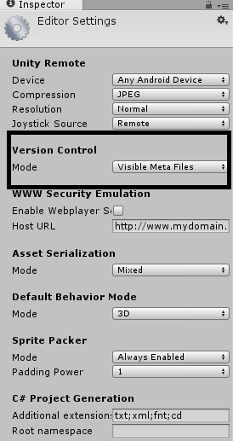

1. Next goto your project directory and find the **audioplugingvrunity.dll** and **Google.ProtocolBuffers.dll.**   
   They will likely be found in **YourProjectName > Assets > Plugins.  
     
   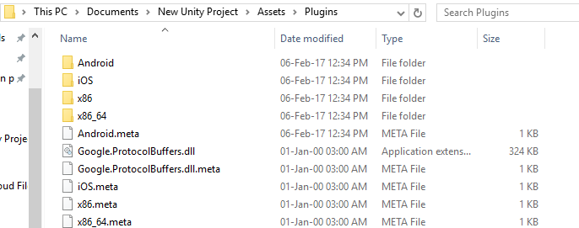**  
   Now, inside the same folder path you found these files, create a new folder and copy and paste these two files in there and zip it up.  
   Upload the new zip file copy of these files into your google drive.
2. Now we can upload your project to github. Make sure to only upload the **Assets** folder and **Project Settings** folder. The meta data in project settings will populate the links.   
   \***NOTE**\*  
   Make sure to make a .gitignore file for your new repo as well. **IF** you are using a pre-existing repo that did not have a .gitignore file you must make a new repo with this file in it unfortunately.  
   To make a .gitignore file, create a new txt document and copy and paste the values in the provided link below.  
     
   <https://github.com/github/gitignore/blob/master/Unity.gitignore>
3. Once your project is uploaded, you and your teammates should be able to clone it. If you get GoogleVR script errors like below, you must download the Plugins.zip file you uploaded to google drive and extract it.  
     
     
   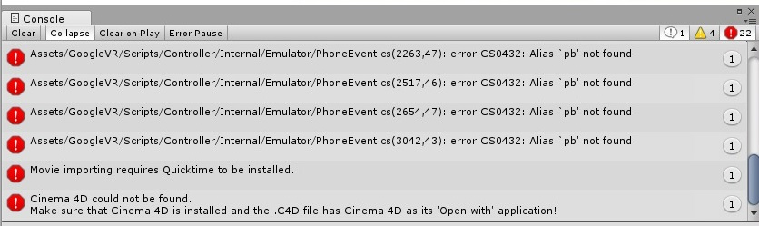
4. After extracting the Plugins.zip folder, simply drag and drop the extracted folder in to your Unity Projects under **Assets**.  
   Now any broken links or missing files should be solved.